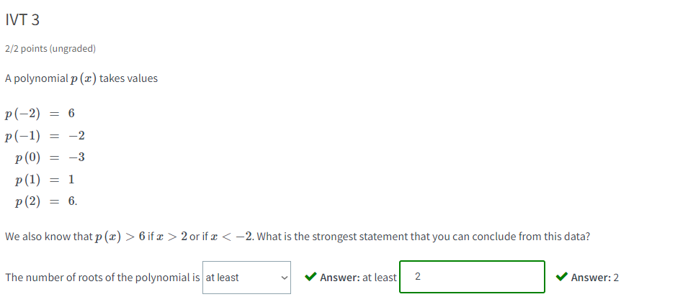

Solution:

Note that any polynomial is continuous at all points, so the Intermediate Value Theorem will apply over any interval.

We know that p(−2) is positive and p(−1) is negative, so there is at least one point between x=−2 and x=−1 where p is zero. Similarly there is at least one point between x=0 and x=1 where p is zero. In total, we know that there are at least 2 roots.

Without graph:

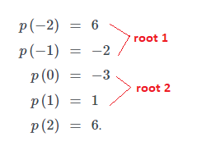

With graph:

